|  |  |
| --- | --- |
|  | **Szymon Babczyński**  Contact: szybabczynski@gmail.com  Github: https://github.com/rvnlord/ |

**Article 3 – DIY: Advanced Technical Analysis with RSI, MACD and EW**

**Prerequisites:**

* General knowledge about basic technical indicators and Elliot waves

I always emphasize that while signals on our website are often excellent, they don’t widen the knowledge of a trader that’s using them for his or her advantage. Why would you want to wait for some brilliant author to provide you with an entry point when during that time you can open and close multiple positions just by doing your own analysis? I think it is more important to feel confident on the market then following blindly even the most successful people. What if a person suddenly stops providing you with their signals? What if the site goes down or if someone starts charging enormous amounts of money for their knowledge? Well, in that case it certainly wouldn’t hurt to have knowledge of your own, would it?

We are going to use *TradingView* charts as they are the most popular and very intuitive. You can launch their website itself or either *Coinigy* or any exchange that directly supports their charts.

The indicators we are going to use are RSI, MACD, Volume and for reference EMA 8, 13, 21, 55, and 200.

Our strategy will be to trade with direct help of the real-time indicators and by anticipating the lagging indicators. Real-time indicators above are RSI, MACD Histogram and Volume. The lagging ones are all the others. To remind everyone the difference: lagging indicators average a set of historical values while real-time ones perform calculations on values that are recent.

The key in every technical analysis is not relying on a single factor but finding confluent reasons to open or close a position. We are going to look for high probability trades with favorable stop losses. It is important to understand that there is no way we can win every trade, we should focus on being right more often than being wrong, that’s where technical analysis shine. It is not meant to be a tool to point you in the right direction 100% of a time.

Also we shouldn’t feel forced to enter a trade at any point in time, we should wait patiently until an opportunity arise. You don’t trade using your feelings, you trade using reason. Your goal is to make rational, well thought decisions. Otherwise there is no point in trading at all.

Let’s first take a look at 6h BTCUSD chart:

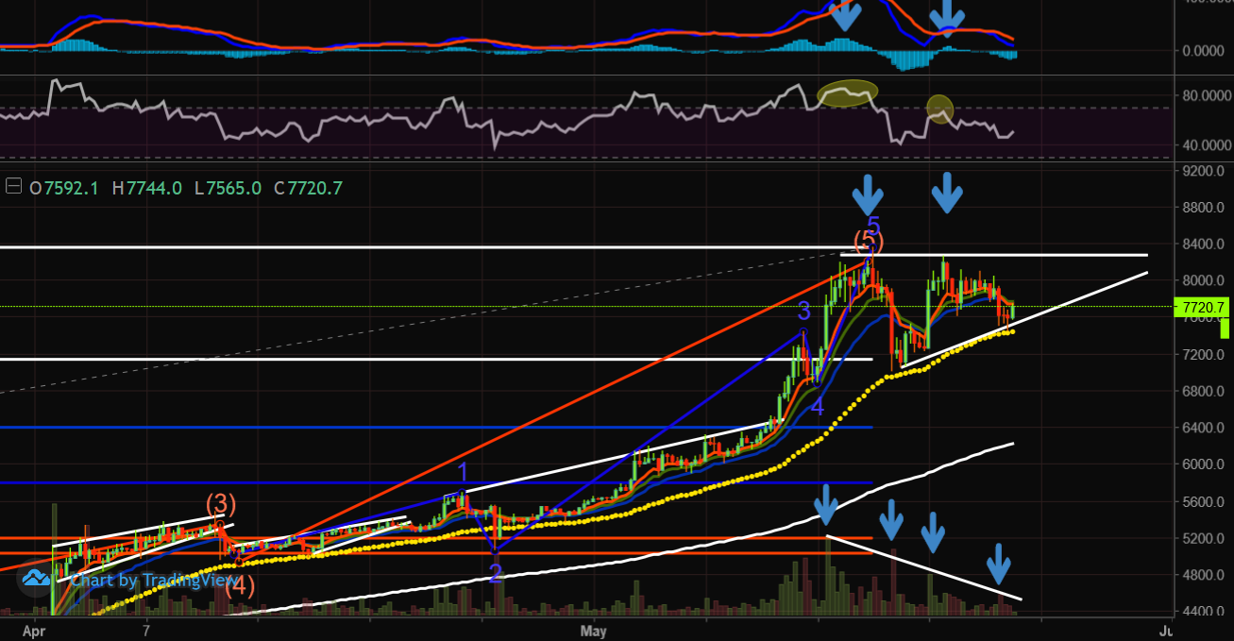

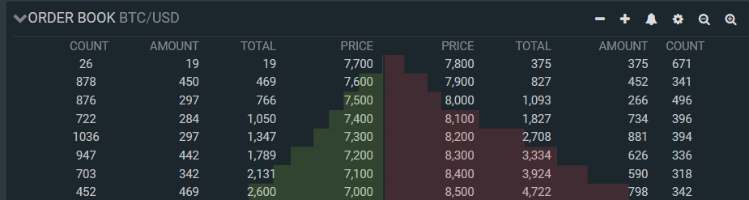

What can we see here?

Bullish:

* We are still clearly above the 55 EMA
* We are potentially forming an ascending triangle and going through the accumulation phase

Bearish:

* We went parabolic and never even retraced to 0.382 fibonacci of the entire structure
* The chart formed double top with lower highs on both MACD histogram and RSI
* The Volume is declining
* At least two previous rising wedges (bearish structures) broke above the sloped resistance
* We have a valid Elliot Wave Count that subdivides nicely into further valid waves, we might be in a process of forming C wave down
* We already overshot 4.236 fibonacci extension drawn from the first wave
* There is an overwhelming dominance of sell orders in the order book

Someone could say that if we would be able to catch the second top confirmed by the MACD histogram downtick we would have an excellent short position, even if we targeted just the 55 EMA. Yes that’s correct and that’s what people often do, but that is already in the past, so it doesn’t matter to us.

What matters is that this setup still looks very bearish, but the question is: is it a good idea to open any position at all now? Well, probably no. Why? Because we would be taking an unnecessary risk. The most reasonable ways to play this are:

* Open a short position if we break the 55 EMA which coincides with breaking the bottom of the ascending triangle, target 0.382 fibonacci (200 EMA) and place stop loss just above the 55 EMA or execute a stop loss if we close above the 55 EMA. Alternatively we could scale the position and add to it until we close above the double top (upper boundary of the triangle).

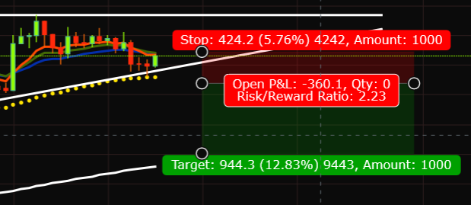

* Open a long position on breakout above the potential ascending triangle if the volume spikes and place a stop loss below the top boundary. We could even place the stop loss below the bottom boundary as the next move and our target would be roughly around 10k which is both the local maximum and the psychological barrier.

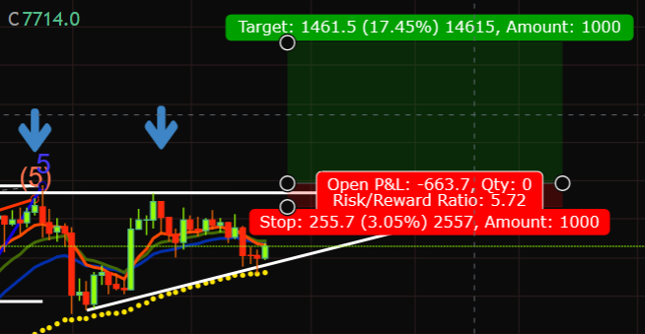

Notice that we should keep our targets and stop losses fluent, they are never hard predefined. If we are long and we start seeing a lot of sells ticking every second on level 2 (trades) then it is most likely the time to consider selling prematurely. Also it is often beneficial to move the stop loss into profit as soon as we start making some and never set the target below 1.00 ratio.

At this point we are still some time away from actually opening a position but as we come closer we could use other chart timeframes to our advantage as well. It is often a good idea to check if a higher timeframe can further reinforce our trading idea or if it shows something entirely different. Lower timeframes on the other hand can show us the current sentiment, the one reflected on level 2. We should also switch to trading based on lower timeframe chart if the spikes are violent enough to provide viable trading opportunities.

Summarizing, be aware that even the most perfect setup can fail, that’s why we should always consider placing a stop loss (especially for short positions) and scaling (dollar cost averaging). Technical analysis is not magic, it involves playing with probability and entering only favorable trades when the opportunity arises.

